

oneM2M
Technical Report
Document Number | oneM2M-TR-0042-V-0.4.0
Document Name: | WoT Interworking
Date: | 2018-5-24
Abstract: | This technical report identifies the interworking scenarios and and its requirements between oneM2M and W3C Web of Things systems and analyze possible architectural solutions to address the requirements.
Template Version: January 2017 (Do not modify)

The present document is provided for future development work within oneM2M only. The Partners accept no liability for any use of this report.
The present document has not been subject to any approval process by the oneM2M Partners Type 1. Published oneM2M specifications and reports for implementation should be obtained via the oneM2M Partners' Publications Offices.

About oneM2M
The purpose and goal of oneM2M is to develop technical specifications which address the need for a common M2M Service Layer that can be readily embedded within various hardware and software, and relied upon to connect the myriad of devices in the field with M2M application servers worldwide.
More information about oneM2M may be found at: http//www.oneM2M.org
Copyright Notification
© 2017, oneM2M Partners Type 1 (ARIB, ATIS, CCSA, ETSI, TIA, TSDSI, TTA, TTC).
All rights reserved.
The copyright and the foregoing restriction extend to reproduction in all media.
Copyright © 2017 W3C® (MIT, ERCIM, Keio, Beihang). Clause 5.2 of this document includes material copied from or derived from W3C Web of Things [xxx].
Notice of Disclaimer & Limitation of Liability
The information provided in this document is directed solely to professionals who have the appropriate degree of experience to understand and interpret its contents in accordance with generally accepted engineering or other professional standards and applicable regulations. No recommendation as to products or vendors is made or should be implied.
NO REPRESENTATION OR WARRANTY IS MADE THAT THE INFORMATION IS TECHNICALLY ACCURATE OR SUFFICIENT OR CONFORMS TO ANY STATUTE, GOVERNMENTAL RULE OR REGULATION, AND FURTHER, NO REPRESENTATION OR WARRANTY IS MADE OF MERCHANTABILITY OR FITNESS FOR ANY PARTICULAR PURPOSE OR AGAINST INFRINGEMENT OF INTELLECTUAL PROPERTY RIGHTS. NO oneM2M PARTNER TYPE 1 SHALL BE LIABLE, BEYOND THE AMOUNT OF ANY SUM RECEIVED IN PAYMENT BY THAT PARTNER FOR THIS DOCUMENT, WITH RESPECT TO ANY CLAIM, AND IN NO EVENT SHALL oneM2M BE LIABLE FOR LOST PROFITS OR OTHER INCIDENTAL OR CONSEQUENTIAL DAMAGES. oneM2M EXPRESSLY ADVISES ANY AND ALL USE OF OR RELIANCE UPON THIS INFORMATION PROVIDED IN THIS DOCUMENT IS AT THE RISK OF THE USER.

Contents
Contents 3
1 Scope 5
2 References 5
2.1 Normative references 5
2.2 Informative references 5
3 Definitions, symbols and abbreviations 5
3.1 Definitions 5
3.2 Symbols 6
3.3 Abbreviations 6
4 Conventions, 7
5 Introduction 7
5.1 Background and Rationale 7
5.1.1 Overview of Interworking in oneM2M 7
5.1.2 Needs for oneM2M – WoT Interworking 7
5.2 Technical comparison of oneM2M and W3C WoT systems 8
5.2.1 Overview of oneM2M system 8
5.2.2 Overview of W3C WoT system 8
5.2.2.1 W3C WoT architecture 8
5.2.2.2 WoT thing description 10
5.2.3 Comparisons of oneM2M and WoT systems 11
6 Interworking Scenarios 12
6.1 Scenario 1: Exposing oneM2M to WoT systems directly 12
6.2 Scenario 2: Integrate WoT system into oneM2M using IPE 13
7 Information Model Mapping and Gap Analysis 14
7.1 WoT Thing Description vs oneM2M Smart Device Template 14
7.1.1 Introduction to Interworking Object (IO) 14
7.2 WoT Thing Description vs oneM2M Base Ontology 18
7.3 WoT Thing Description vs oneM2M Resource Model in General 18
8 Potential Architectural Solutions and Implementation Guidance 18
8.1 Exposing oneM2M entities as WoT servients by TD 18
8.2 Integrate WoT system into oneM2M using IPE 18
8.2.1 Solution 1: Direct Resource Mapping 18
8.2.2 Solution 2: Using Generic Interworking Framework 18
8.2.3 Solution 3: Transparent Interworking 18
8.3 Cross-system Discovery between oneM2M and WoT Systems 18
Editor’s Note: It is for further evaluation whether the cross-system discovery solution in this clause can be generalized to other systems and applied to oneM2M TS-0033. 18
8.3.1 Use Case 18
8.3.2 Overview of Cross-system Discovery Service (CDS) 20
8.3.3 Various Discovery Mechanisms Supported by CDS 20
8.3.3.1 Solution 1: Proactive Cross-system Discovery and Proactive IO Creation 20
8.3.3.2 Solution 2: Proactive Cross-system Discovery and Reactive IO Creation 21
8.3.3.3 Solution 3: Reactive Cross-system Discovery and Reactive IO Creation 21
8.3.3.4 Solution 4: No IO Creation Is Created for Each of Discovered Things 21
8.4 IO Lifecycle Management between oneM2M and WoT Systems 21
8.4.1 Introduction 21
8.4.2 Overview of IO Lifecycle Management Service (IO-LMS) Description 22
8.4.3 High-Level Solutions to IO-LMS 23
8.4.3.1 IO Creation Process 23
8.4.3.2 IO Update Process 23
8.4.3.3 IO Deletion Process 23
9 Conclusion 24
Annexes 24
History 25

1 Scope
The present document describes the interworking scenarios between the oneM2M and W3C WoT systems and the potential interworking solutions to achieve semantic interoperability. The scope includes the following aspects:
- Technical comparison of oneM2M and W3C WoT systems
- Interworking scenarios between oneM2M and W3C WoT systems
- Information modelling mapping between oneM2M SDT/ Base Ontology and W3C WoT TD, including alignment suggestion for the future evolution.
- Potential architectural solutions and implementation guidance of interworking between oneM2M and W3C WoT systems.

2 References

2.1 Normative references
Not applicable.

2.2 Informative references
The following referenced documents are not necessary for the application of the present document but they assist the user with regard to a particular subject area.
- oneM2M Drafting Rules (http://member.onem2m.org/Static_pages/Others/Rules_Pages/oneM2M-Drafting-Rules-V1_0.doc)
- oneM2M TS-0001, Functional Architecture, v2.10.0, August 2016.
- Web of Things (WoT) Architecture, W3C Editor's Draft, May 4, 2017 (https://w3c.github.io/wot-architecture/)
- Web of Things (WoT) Thing Description, W3C Editor's Draft 27th April 2018 (https://w3c.github.io/wot-thing-description/)
- World Wide Web Consortium (W3C), Semantic Web (https://www.w3.org/standards/semanticweb/)
- oneM2M TS-0023, Home Appliances Information Model and Mapping, V3.7.0, Jan. 18, 2018.
- oneM2M TS-0012, Base Ontology, v3.6.0, January 08, 2018.
- oneM2M TS-0030, Ontology based Interworking, v0.4.1, January 08, 2018

Editor’s Note: All references (espeically those from WoT) should be updated before publication.

3 Definitions, symbols and abbreviations

3.1 Definitions
Clause numbering depends on applicability.
- A definition shall not take the form of, or contain, a requirement.
- The form of a definition shall be such that it can replace the term in context. Additional information shall be given only in the form of examples or notes (see below).
- The terms and definitions shall be presented in alphabetical order.
For the purposes of the present document, the [following] terms and definitions [given in ... and the following] apply:
Definition format
<defined term>: <definition>
If a definition is taken from an external source, use the format below where [N] identifies the external document which must be listed in Section 2 References.
<defined term>[N]: <definition>
example 1: text used to clarify abstract rules by applying them literally
NOTE: This may contain additional information.

3.2 Symbols
Clause numbering depends on applicability.
For the purposes of the present document, the [following] symbols [given in ... and the following] apply:
Symbol format
<symbol> <Explanation>
<2nd symbol> <2nd Explanation>
<3rd symbol> <3rd Explanation>

3.3 Abbreviations
Abbreviations should be ordered alphabetically.
Clause numbering depends on applicability.
For the purposes of the present document, the [following] abbreviations [given in ... and the following] apply:
Abbreviation format
AE Application Entity
API Application Program Interface
ASN Application Service Node
BO Base Ontology
CRUD Create, Retrieve, Update, Delete
CSE Common Service Entity
CSF Common Service Function
IG Interest Group
IN Infrastructure Node
IoT Internet of Things
IPE Interworking Proxy Entity
JSON JavaScript Object Notation
JSON-LD JavaScript Object Notation for Linked Data
MN Middle Node
RDF Resource Description Framework
ROA Resource-Oriented Architecture
SDT Smart Device Template
TD Thing Description
URI Uniform Resource Identifier
WG Working Group
WoT Web of Things

4 Conventions,
The key words “Shall”, ”Shall not”, “May”, ”Need not”, “Should”, ”Should not” in this document are to be interpreted as described in the oneM2M Drafting Rules [i.1]

5 Introduction

5.1 Background and Rationale
Editor’s note: short background and the benefits of oneM2M – WoT interworking

5.1.1 Overview of Interworking in oneM2M
Interworking provides entities from incompatible systems with the framework and ability to communicate and interact with each other. A system compliant to a standard X (such as oneM2M) can be called X-compliant. A native thing/device in an X-compliant system will be called an “X-compliant thing/device”. Similarly, native users/applications in the X-compliant system can interact with the X-compliant devices/things without leveraging any interworking technologies. However, X-compliant users/applications must leverage interworking technologies in order to interact with Y-compliant things/devices.
In general, interworking requires certain new logic functionality, which acts as a translator or intermediator between systems which are compliant to different standards. In oneM2M functional architecture [i.2], Interworking Proxy Entity (IPE) is the logic entity that handles interworking between the oneM2M system and an external system. For a given external device that is X-compliant such as W3C Web of Things (WoT), IPE will create corresponding oneM2M resource representation (as “avatar”) in the oneM2M system and this resource representation will then provide oneM2M-compliant interface. Accordingly, oneM2M users/application can issue RESTful operations (i.e. Create, Retrieve, Update, and Delete which are referred to as CRUD) directly on this resource, which will be captured by the IPE and translated to native operations in external X-compliant system; then IPE sends those native operations to the external device and eventually realize the interworking from oneM2M users/applications to X-compliant device. For the reverse interworking from X-compliant devices to oneM2M users/applications, IPE follows the similar process but translates native operations in the X-compliant system to oneM2M RESTful operations.

5.1.2 Needs for oneM2M – WoT Interworking
In real Internet of Things (IoT) scenarios, due to the lack of or no coordination among different parties/organizations, it is possible that IoT things/devices deployed by different parties may be compliant to different standards. For example, considering a downtown scenario in a smart city, different parties may deploy their outdoor cameras for various civic purposes such as traffic control, security monitoring, and parking spot management. An application identifying street parking may use the latest images captured around the street by a variety of cameras which may be compliant to different standards
IoT applications or IoT devices may have limited capabilities and will not support multiple standards simultaneously for cost saving or other purposes. For example, some of deployed cameras along streets are only compliant to World Wide Web Consortium (W3C) Web of Things (WoT) standard [i.3] while the user interfaces through an oneM2M application. As a result, the user will not be able to retrieve images from those WoT-compliant cameras unless certain interworking mechanism can be designed and leveraged. Overall, it can be seen that interworking is an essential technology to realize various IoT applications in reality which needs interoperability across oneM2M and W3C WoT.

Editor’s note: W3C WoT Interest Group (IG) and Working Group (WG) are still ongoing. The content about W3C WoT in this technical report is based on the latest progress in W3C WoT IG and WG, and shall be reexamined and updated according to future deliverables from W3C WoT IG and WG.

5.2 Technical comparison of oneM2M and W3C WoT systems
Editor’s note: technical introduction to W3C WoT (e.g. architecture, TD) and comparison between two systems, including similarities and differences in terms of architectural style (RESTful), resource modelling, semantics.
Editor’s note: clear statement about which specific part of the content is copied from W3C shall be provided.

5.2.1 Overview of oneM2M system
The goal of oneM2M is to develop technical specifications which address the need for a common service layer that can be readily embedded within hardware apparatus and software modules in order to support a wide variety of devices in the field. As specified in oneM2M TS-0001 [i.2], the oneM2M common service layer supports a set of Common Service Functions (CSFs) (i.e. service capabilities). An instantiation of a set of one or more particular types of CSFs is referred to as a Common Service Entity (CSE) which can be hosted on different types of network nodes (e.g. Infrastructure Node (IN) and Middle Node (MN), and Application Service Node (ASN)). The CSEs provide the service capabilities to other CSEs as well as to Application Entities (AEs). Typically, an AE represents an instantiation of application logic for end-to-end M2M solutions, for example, an instance of a fleet tracking application, a remote blood sugar monitoring application, a power metering application, or a controlling application, etc. oneM2M service layer is developed based on Resource-Oriented Architecture (ROA) principle, in the sense that different resources and RESTful operations on them are specified in oneM2M functional architecture to support different CSFs. A resource is uniquely addressable using Uniform Resource Identifiers (URIs) and can be manipulated via RESTful CRUD operations. A resource may contain child resource(s) and attribute(s). For example, a parent resource can represent an oneM2M device while its child resources can further represent the operations or properties of this device.

5.2.2 Overview of W3C WoT system

5.2.2.1 W3C WoT architecture
WoT functional architecture has been designed with three primary requirements [i.3]: flexibility by aiming to support a wide range of physical WoT devices, upper compatibility to current IoT standards and legacy IoT solutions, and security and privacy. In WoT system, the major functional entity is “WoT Servient” which is an entity consisting of a web client, a web server, and device control capabilities. A WoT Servient becomes a WoT Server if it only has a web server and device control capabilities, or a WoT client if it does not have a web server but a web client. Through a WoT Servient, IoT physical devices can be accessed, monitored, and controlled (e.g. to get their status and data values from those devices).
The general WoT Servient functional architecture as defined in [i.3] is presented in Figure 5.2.2.1-1. Servients communicate with each other through “WoT Interface”, a resource-oriented Web Application Program Interface (API). A Servient can be in client role (i.e., it only consumes other things), server role (i.e., it only exposes things and provides capabilities), or both. As defined in [i.4], “Thing” is the abstract concept of a physical entity that can either be a real-world artifact, such as a device, or a virtual entity that represents physicality, such as a room or group of devices. In general, a WoT Thing (e.g., a legacy device only providing proprietary interface) has an associated WoT Servient, which is the representation of this Thing in the WoT system, with which other WoT Servients can interact. Servients can also provide access to virtual things such as a collection of physical things (e.g., all lights in a room). In addition, Servients can be hosted in different places such as inside a smartphone, a local gateway, or the cloud.
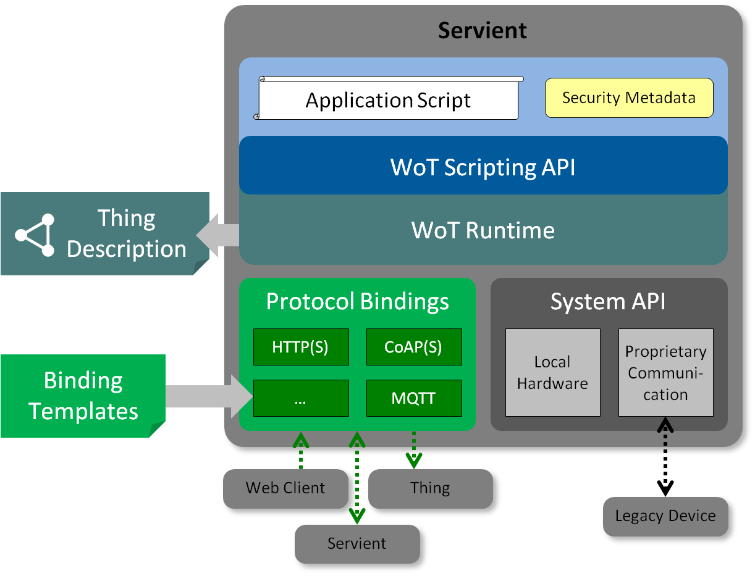
Figure 5.2.2.1-1: Functional Architecture of WoT Servient [i.3]
According to [i.3], the functionalities of several major modules of a WoT Servient are described below.
- Thing Description: Each WoT Thing is described by a WoT TD, which basically describes the semantics of a Thing as well as its WoT Interface. The TD must be acquired before it the Thing can be accessed and/or interested with. Things can provide their own TDs locally, but the TD can also be hosted externally (e.g. if there is not enough space on the thing/device). To ease TD discovery, TDs can be registered with a well-known TD Repository, where the TD for Things of interest can be queried. The Clause 5.2.2.2 gives more details about TD.
- Appication: The application logic of a WoT Thing (or technically a servient) can be implemented natively, for instance in the device firmware, which is expected to be common for very resource-constrained Things. Following the patterns in the Web, however, application logic should also be provided by scripts. This is supported through a scripting runtime environment—similar to the Web browser—that may be provided by a servient. App scripts implement application logic in a modular and portable way. It can access local hardware, locally connected legacy devices, and remote things through the WoT Interface.
- Script API: Portability of such scripts is ensured through a common Scripting API (i.e. Client API, Server API, Discovery API, and Proprietary API) that allows an application to discover things (via Discovery API), to consume things (via Client API), to expose things (via Server API), and/or to access/control the hardware physically attached to the servient (via Proprietary API). Scripting API is more like an internal API used by application scripts, while the WoT Interface is the external interaction interface between different WoT Servients.
- Protocol Binding: It supports binding Script API messages to different underlying protocols with various communication patterns such as push, pull, pub-sub and bi-directional messaging. After protocol binding, message will be transmitted over WoT interface from one WoT Servient to another WoT Servient. This will be realized by standardized Binding Template.
- Security and Privacy: Security and privacy features will be embedded in other modules like TD, Script API, Protocol Binding, etc. As a result, W3C WoT WG will not generate a standalone specification for security and privacy, but include security and privacy design in TD specification, Script API specification, and binding template specification.
W3C WoT WG does not specify Applicattion, but specifies Thing Description (TD), Script API, and Protocol Binding Template.
Editor’s note: all the description about WoT Architecture needs to be revisited/revised according to the latest version of W3C WoT before oneM2M publication. The “Security and Privacy” part may need to be removed.

5.2.2.2 WoT Thing Description (TD)
WoT TD is the key module to enable interactions between two WoT Servients, and plays a critical role in oneM2M-WoT interworking (e.g. mapping between W3C TD model and inforamtion models in oneM2M).
WoT TD can be considered as the entry point of a Thing (aka the index.html of the Thing). It consists of semantic metadata for the Thing itself, a narrow-waist interaction model with WoT's Properties, Actions, and Events, a semantic schema to make data models machine-understandable, and features for Web Linking to express relations among Things [i.4].
Currently WoT TD uses JSON-LD as its default serialisation format, while other formats (e.g. plain JSON) are also under investigation. Using JSON-LD implies the semantic layer capability of WoT TD, which follows the Linked Data and RDF practices in the Semantic Web [i.5] world. In fact, the core set of WoT TD consists of a limited set of vocabulary in terms of classes, its fields (i.e. properties) and relations, which comprises the ontology of TD ‘Core Model’ as illustrated in Figure 7.2-1 [i.4]. Detailed definintions and more examples can be found in [i.4].
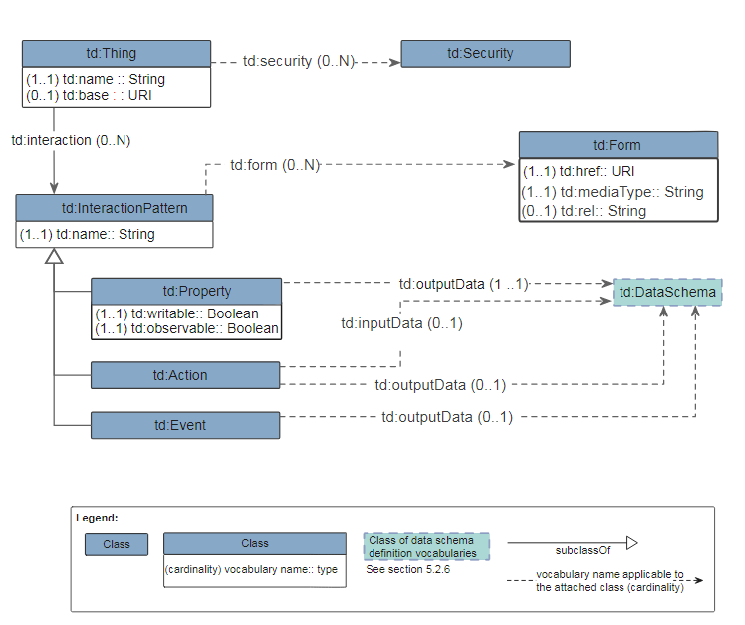
Figure 7.2-1 TD Core Model
Editor’s note: all the description about WoT TD needs to be revisited/revised according to the latest version of W3C WoT before oneM2M publication.

5.2.3 Comparisons of oneM2M and WoT systems
According to [i.2] for oneM2M and [i.3]-[i.5] for W3C WoT, oneM2M and W3C WoT systems share the following commonalities:
- Both are based on the RESTful design principle. For example, a resource in oneM2M has a URI and can be manipulated via CRUD operations. Similarly, as illustrated in Figure 5.2.2.2-2, Properties/Actions/Events on a Things are described as resources; each has a URI and can be accessed (e.g. Retrieve and Update).
- Both can bind to various communication protocols (e.g. HTTP, CoAP, MQTT, etc.).
- Both use RDF to describe semantic metadata about a thing (in W3C WoT) or a resource (in oneM2M).
- Both can leverage external ontologies.
- TD model in W3C WoT and Smart Device Template (SDT)/Base Ontology in oneM2M provide similar information.
Several differences between the oneM2M and the W3C WoT systems have been identified below. Although this is not an exhaustive list, it needs to be taken into account when designing interworking solutions between the two systems.
- oneM2M provides a common Service Layer that includes a set of CSFs describing service aspects. By comparison, W3C WoT does not specify common service functions in a TD.

- A WoT Thing is associated with a WoT Servient, and in the meantime, a WoT Thing has a corresponding TD which describes how to interact with this thing through its corresponding servient. In other words, the TD can be separated from the WoT thing or its servient in the sense that the TD can be regarded as a user manual and can be hosted/published to a TD repository. By comparison, in oneM2M system, there is not such a “description” or “manual” for interacting with oneM2M devices/resources.

- The <semanticDescriptor> resource defined in oneM2M is different from the TD defined in the W3C WoT system. The <semanticDescriptor> resource provides additional metadata as semantic annotations for a particular resource. In contrast, the TD describes more aspects about a whole thing (e.g. semantic metadata, security, interaction patterns and communication binding details), not limited to a single resource. At the same time the TD in W3C WoT uses a more centralized approach, while the <semanticDescriptor> resource in oneM2M is more distributed.

- Reference points specified in oneM2M include functionalities and protocol aspects. In contrast, W3C WoT does not specify functionalities although they can be described in TD; the protocol aspects of WoT defined in the TD are restricted to the use of a few keywords, which may not be sufficient to support oneM2M reference points (e.g. oneM2M-specific protocol extensions such as HTTP headers).

- oneM2M provides sophisticated filters for resource discovery. In contrast, only discovery of TDs is needed in W3C WoT system. The discovery of TDs targets the whole TD document, not a particular resource or a specific type of resources hosted on a thing.

6 Interworking Scenarios

6.1 Scenario 1: Exposing oneM2M to WoT systems directly
Editor’s note: describing the scenario that oneM2M entities are exposed as WoT servients by WoT TD, so that a native WoT servient (client/server) may interact with the oneM2M system (AE/CSE), ideally without knowing technology specifics of oneM2M.
This scenario is for the case that oneM2M nodes (in physical form of devices, gateways or platforms) are exposed as WoT Servients (in the server role) based on the metadata description of WoT TD. The objective is to enable a native WoT Servient (i.e. in the client role) to interact with the oneM2M nodes and consume the services and data provided by the oneM2M service layer via Mca/Mcc reference point, while with minimal (ideally none) requirement on the knowledge of oneM2M interface specifications. In other words, a WoT Servient can become oneM2M compliant and consume oneM2M interfaces according to the WoT TD of the oneM2M interfaces.
The architectural view of this scenario is shown in Figure 6.1-1. A oneM2M ASN/MN/IN (containing CSE) can directly host services and data as oneM2M resources and exposes them via RESTful APIs (Mca/Mcc) over different protocol bindings. As long as the oneM2M resource model and protocol bindings can be well expressed in WoT TD, the ASN/MN/IN can be modelled as a WoT Servient (Server) and interact with a native WoT Servient (Client) based on the WoT specifications. From oneM2M perspective, the WoT Servient (Client) may act as either an AE or CSE depending on whether Mca or Mcc is used. The latter case implies the WoT Servient (Client) itself also hosts oneM2M resources and may expose a corresponding TD as well. An ADN (containing only AE) cannot host and expose resources directly, but may still be represented as a standalone WoT Servient based on its registered resource model on a registrar CSE in an ASN/MN/IN.
The TD describing a oneM2M node as a WoT Servient can be hosted anywhere in the oneM2M system in theory. In this study, it’s recommended to co-locate the TD of a oneM2M node in the local CSE (for ASN/MN/IN) or the registrar CSE (for ADN).
Thing Description

Resource Model
Protocol Binding
AE
CSE
oneM2M ASN/MN/IN
(WoT Servient - Server)
Mca
WoT i/f (Mca/Mcc)
Protocol Binding
(oneM2M)
Resource Model
App Script
AE
oneM2M ADN
(WoT Servient - Server)
Mca
WoT Servient - Client
(oneM2M AE/CSE)

Figure 6.1-1 oneM2M-WoT Interworking Scenario 1: Exposing oneM2M to WoT systems directly

6.2 Scenario 2: Integrate WoT system into oneM2M using IPE
Editor’s note: describing the scenario that WoT servients are integrated into a oneM2M system via the IPE, so that WoT data can be exchanged within the oneM2M system as resources.

This scenario is for the case that WoT Servients are represented as interworked devices in the oneM2M system via IPE. The objective is to enable a native oneM2M AE to interact with the WoT Servients and consume the services and data provided by the WoT Servients in the form of oneM2M resources mapped by the IPE, while with minimal (ideally none) requirement on the knowledge of WoT specifications.
The architectural view of this scenario is shown in Figure 6.2-1. An oneM2M IPE acting as a WoT Servient (Client) can interact with a native WoT Servient (Server) based on the TD of the WoT Servient (Server). The IPE then maps the WoT resource model described in the TD into oneM2M resource model in a hosting CSE of a ASN/MN/IN. From that on, any oneM2M entity (AE/CSE) may consume the service and data provide by the WoT Servient as represented in the mapped oneM2M resources via Mca/Mcc reference points. In case the WoT Servient’s TD is changed/updated later, the IPE needs to update the previously mapped resource model in the hosting CSE accordingly. In the reverse direction, update to the mapped resource representation may also be reflected back by the IPE to the interworked WoT Servient (Server) accordingly.
Depending on different mechanisms (e.g. transparent or semantic) of the resource model mapping between oneM2M and WoT TD, a oneM2M entity (AE/CSE) interworking with a WoT Servients may or may not need to understand the information model of WoT TD.
AE
CSE
oneM2M ASN/MN/IN
Mca
WoT Servient
(Server)
Protocol Binding
Resource Model
App Script
Thing Description

IPE
(WoT Servient - Client)
Mca
Mcc
WoT i/f
Resource Model
Protocol Binding
Figure 6.1-1 oneM2M-WoT Interworking Scenario 2: Integrate WoT system into oneM2M using IPE

7 Information Model Mapping and Gap Analysis
Editor’s note: the following sub-clause titles are provisional and subject to change during further study.

7.1 Introduction to Interworking Object (IO)
To realize interworking, a thing in a system that is compliant to a specific standard may have a corresponding representation in another system which is compliant to a different standard. Such corresponding representations for supporting interworking are referred as “Interworking Objects (IOs)”.
Below is a TD example and Figure 7.1-1 shows the TD of the WoT-complaint LED-Light-123 [i.5], which shows that:
- The light has a Property called “status” (The green part), which can be used to check the current status of the light, and can also be used to control the power of the light.
- The light has an Action called “fadeIn” (The pink part), which can be used to adjust the brightness of the light.
- The light has an Event called “onOffStatusNotification” (The blue part), which can be used to send alerts or notifications.

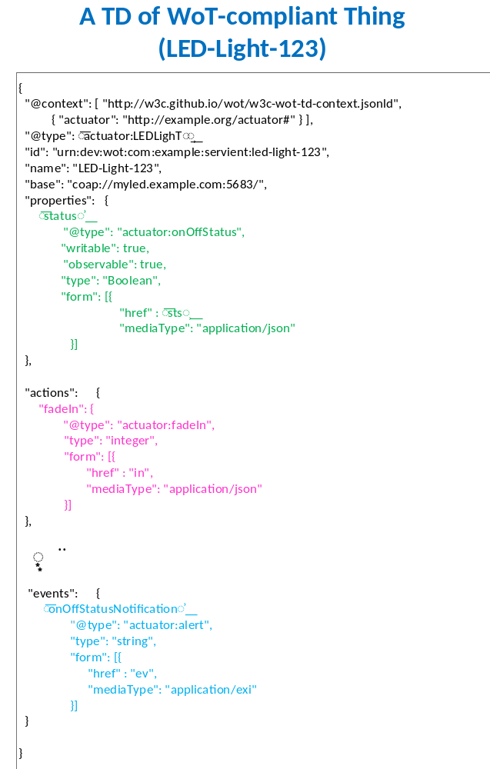
Figure 7.1-1 WoT Thing Description of LED-Light-123

7.2 WoT Thing Description vs oneM2M Smart Device Template
This clause describes how to map WoT TD to oneM2M Smart Device Template. In general, WoT TD [i.4] defines a limited set of vocabulary in terms of classes and its fields (i.e. properties). The collection of the classes and relations comprises the ontology of TD ‘Core Model’. In the meantime, oneM2M TS-0023 [i.6] provides the unified means in the oneM2M system by defining a Home Appliance Information Model (HAIM) for the home domain devices such as TV, refrigerator, air conditioner, clothes washer, oven, and robot cleaner. The principle of the HAIM is designed based on HGI Smart Device Template (SDT) 3.0.
Below are the details about information model mapping between oneM2M SDT and WoT TD. First, Table 7.2-1 shows the proposed mapping relationships between SDT Concepts and Classes/Properties in WoT TD.
Editor’s note: the remaining mapping details will evolve over time based on the standard progress on both WoT side and oneM2M side.
Table 7.2-1: Mapping between oneM2M SDT and WoT TD Information Model
SDT Concept | Class/Property in TD | Note
SDT:Device | td:Thing | For a given TD of a WoT Thing, the semantic annotation as described by @type can be used to decide which SDT/HAIM device model can be adopted as the IO for this WoT Thing. For example, if @type of a WoT Thing refers to a “Light” concept defined by an ontology, then this WoT Thing can potentially to be mapped to a oneM2M HAIM light device.
SDT:SubDevice | td:Thing | oneM2M SDT may allow sub devices, while TD does not support sub device modelling.  Editor’s Note: It is considered as a gap that whether a SDT sub device can be modelled as a general WoT Thing, which is for further study.
SDT:DataPoint | td:Property | For a given property of a WoT Thing, the semantic annotation as descried by @type can be used to decide which datapoint of a SDT device model should be mapped to. For example, in Figure 7.1-1, the WoT property “status” with the annotation ("actuator:onOffStatus") can be mapped to the powerState DataPoint in the corresponding HAIM Light device.
SDT:Property | td:Property | Similar to SDT datapoint, a SDT property can be mapped to a WoT property.
SDT:Action | td:Action | For a given WoT action of a WoT Thing, the semantic annotation as descried by @type can be used to decide which action of the SDT/HAIM device model should be mapped to. For example, in Figure 7.1-1, the WoT action “fadeIn” with the annotation ("actuator:fadeIn") may potentially be mapped to a fadeIn Action if the corresponding HAIM brightness ModuleClass device also support such an action.
SDT:Event | td:Event | A WoT event can be mapped to a <subscription> child resource of the resource representing the whole SDT device, e.g., the <LED-Light-123> resource shown in Figure 7.2-2.
SDT:ModuleClass | td:interaction  Editor’s Note: The latest TD ontology introduced three vocabularies, i.e. td:properties, td:actions, td:events (as containers) for each of specific interaction pattern types (Property, Action, Event), which are used in a TD in order to group the same type of behaviours of a thing. | A SDT ModuleClass is a mixed collection of structured property/action/dataPoint, which is to describe a logical function/component of a SDT device. However, TD models a thing in another way (i.e., the behaviours belonging to the same interaction pattern type (e.g. Property, Action, Event) are grouped together.  Accordingly, SDT ModuleClass concept may not have direct/appropriate mapping to those specific interaction pattern types (i.e., td:properties, td:actions, td:events,).
SDT:Module | The instance of a specific interaction pattern type (i.e., td:properties, td:actions, td:events) in a TD. | Each SDT:Module implements one SDT:ModuleClass while an instance of td:properties (td:actions or td:events) in a specific TD defines a group of behaviours of a WoT thing belonging to that interaction pattern type.

In addition to the above mapping relationships shown in Table 7.2-1, some of the SDT concepts may not have direct/appropriate mapping to WoT classes/properties. Accordingly, some of the detour solutions/rules to those cases are proposed as below:
- td:writable: td:writable indicates whether a td:Property is writable or not. Accordingly, a writable TD property shall be mapped to a SDT datapoint that is also writeable.
- td:observable: td:observable indicates whether a remote servient can subscribe to ("observe") a td:Property. Accordingly, the corresponding mapped SDT datapoint of an observable TD property shall also be observable (e.g., could have a <subscription> child resource).
- td:Schema / td:inputSchema / td: outputSchema: All the three WoT interaction types (i.e., Property, Action, and Event) include data schema definitions. For the data schema of a WoT property, it shall be compliant to the datatype of corresponding mapped SDT datapoint. For the data schema of a WoT action, it shall be compliant to the datatype of the SDT datapoint that is used by the mapped SDT action.
- td:name: td:name can be used to annotate the name of a thing. Accordingly, the name of a WoT thing may be used as the resource name of the corresponding mapped SDT device.
Next, a mapping example is illustrated based on the mapping relationship as defined above, which shows how a WoT-compliant LED light (i.e., LED-Light-123 as shown in Figure 7.1-1) can be made available in the oneM2M system through creating an IO (i.e., a HAIM light) in the oneM2M system. An IO can be created in the oneM2M system for LED-Light-123, which is shown in Figure 7.2-1. For example:
- The oneM2M resource <LED-Light-123> (including its child resources) is the IO of LED-Light-123 in the oneM2M system. In other words, LED-Light-123 is modelled as a HAIM light since the containerDefinition attribute of <LED-Light-123> indicates that this resource represents a HAIM light, which therefore can be accessed by native oneM2M entities.
- The “status” property in the TD of LED-Light-123 is mapped to the attribute of <powerSwitch-of-Light-123> resource, whose containerDefinition attribute indicates that this resource represents a module class of binarySwitch. In particular, the powerState DataPoint is used to model the “status” property in the TD of LED-Light-123.
- The “fadeIn” action (same for “fadeOut” action, which is not shown in Figure 7.1-1 due to the limited space) in the TD of LED-Light-123 can potentially be mapped to the attributes and child resources of <lightBrightness-of-Light-123> resource, whose containerDefinition attribute indicates that this resource represents a module class of brightness. Note that, in current TS-0023, the brightness module class does not describe fade-in or fade-out actions so far. If it will support such feature in a future release, it can better model the fadeIn action. For example, a <fadeIn> resource (representing an action defined by the brightness module class) can be used to model the “fadeIn” action.
- The “onOffStatusNotification” event in the TD of LED-Light-123 is mapped to oneM2M <subscription> resource.
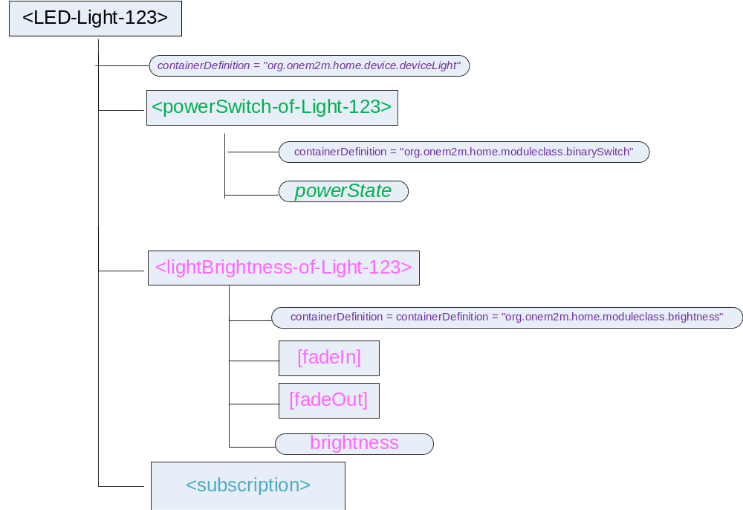
Figure 7.2-1 The IO of WoT-compliant LED-Light-123

7.3 WoT Thing Description vs oneM2M Base Ontology
WoT TD has less classes defined than oneM2M Base Ontology (BO) [i.7] in general, but has some specific classes and fields (properties) that are not directly mappable to oneM2M BO. Table 7.3-1 and Table 7.3-2 show the mapping relationships of the Classes and the Properties (both Object Properties and Data Properties) between WoT TD and oneM2M BO respectively.
Table 7.3-1: Class mapping between WoT TD and oneM2M BO
Class/Property in TD | Mapping relationship | Class/Property in BO | Note
td:Thing | owl:equivalentClass | oneM2M:Thing | a td:Thing can be a physical and/or virtual Thing
td:InteractionPattern | owl:subClassOf | oneM2M:Service | -
td:Property | owl:subClassOf* | oneM2M:ThingProperty  oneM2M:OutputDataPoint | a td:Property can be a static, non-functional property of a thing or a dynamic and functional (output) data point of a thing.
td:Action | owl:subClassOf | oneM2M:Operation | -
td:Event | owl:subClassOf | oneM2M:Operation | -
td:DataSchema | owl:subClassOf | oneM2M:Variable | td:DataSchema
td:Form | N/A | N/A | td:Form is to provide the metadata (e.g. URI, mediaType) for accessing a service (td:InteractionPattern) of a thing.  There is no direct mapping in oneM2M BO.
td:Security | owl:subClassOf | oneM2M:ThingProperty | There is no direct mapping in oneM2M BO, but security can be consider as a property of a thing.

Table 7.3-2: Property mapping between WoT TD and oneM2M BO
Class/Property in TD | Mapping relationship | Class/Property in BO | Note
td:name (of td:Thing) | owl:subPropertyOf | oneM2M: hasThingAnnotation | In the case that td:name is used to annotate the name of a thing, it can be mapped as a subProperty of oneM2M:hasThingAnnotation which can be used to annotate a thing in many ways including the name.
td:name (of td:InteractionPattern) | owl:subPropertyOf | oneM2M:hasOutputDataPoint | In the case that td:name is used to annotate the name of an instantiated td:InteractionPattern (which is mapped as a subclass of oneM2M:Service), it can be mapped as a subProperty of oneM2M: hasOutputDataPoint, which can link to a specialized oneM2M:OutputDataPoint that annotates the name of the oneM2M:Service.
td:security | owl:subPropertyOf | oneM2M:hasThingProperty | There is no direct mapping in oneM2M BO, but security can be consider as a property of a thing.
td:interaction | owl:subPropertyOf | oneM2M:hasService | -
td:outputData | owl:subPropertyOf | oneM2M:hasOutputData  oneM2M:hasOutput | If the domain class (subject) is a td:Property, it’s mapped to oneM2M:hasOutputData. If the domain class (subject) is a td:Action or td:Even, it’s mapped to oneM2M:hasOutput
td:inputData | owl:subPropertyOf | oneM2M:hasInput | -
td:observable | N/A | N/A | td:observable is to indicates whether a remote servient can subscribe to ("observe") a td:Property. There is no proper mapping in oneM2M BO.
td:writable | N/A | N/A | td:writable is to indicates whether whether a td:Property is writable or not. There is no proper mapping in oneM2M BO.
td:base | owl:subPropertyOf* | oneM2M:oneM2MTargetURI | td:base is the base URI of all local interactions. It may or may not be a oneM2M URI depending on whether the described thing is a oneM2M entity or not.
td:href | owl:subPropertyOf* | oneM2M:oneM2MTargetURI | td:href can be a relative URI based on the td:base URI or an absolute URI. It may or may not be a oneM2M URI depending on whether the described thing is a oneM2M entity or not.
td:mediaType | N/A | N/A | td:mediaType describes the IANA media type of the interaction pattern.  There is no proper mapping in oneM2M BO.
td:rel  Editor’s note: it’s not well defined in WoT yet. | N/A | N/A | td:rel Provides the expected result of performing the operation described by the td:Form.  There is no proper mapping in oneM2M BO.

NOTE: The mapping relationship with a ‘*’ mark in Table 7.3-1 represents a reversed relationship (from oneM2M BO to WoT TD).
According to the analysis above, it’s noticed that not all WoT TD classes and properties can be directly mapped to oneM2M BO. There may be information losing (e.g. td:Form) if the ‘Ontology-based Interworking’ mechanism defined in [i.8] is applied to the oneM2M-WoT interworking based on the ontology mapping to oneM2M BO.
Editor’s Note: mapping highlighted in yellow needs FFS before conclusion.
Editor’s Note: Extension to oneM2M BO may need to be considered in order to better support the interworking with WoT. On the other hand, it’s ffs if all TD information requires to be mapped or not. td:Form metadata for accessing WoT services may be hidden by IPE, so no need to be mapped and exposed.

7.4 WoT Thing Description vs oneM2M Resource Model in General
Editor’s note: compare the information/metadata described in WoT TD and by different types of oneM2M resources (e.g. <semanticDescriptor>, <conatiner>, <AE>)

8 Potential Architectural Solutions and Implementation Guidance
Editor’s note: the following sub-clause titles are provisional and subject to change during further study.

8.1 Exposing oneM2M entities as WoT servients by TD
Editor’s note: study how oneM2M resource trees and binding interfaces can be described by WoT TD, so that a native WoT servient (client/server) may interact with the oneM2M system (AE/CSE), ideally without knowing technology specifics of oneM2M.

8.2 Integrate WoT system into oneM2M using IPE

8.2.1 Solution 1: Direct Resource Mapping
Editor’s note: this solution envisions the interworking approach of mapping WoT data model directly to oneM2M resources e.g. <flexContainer> by defining mapping rules similar to those defined in TS-0023. In this approach, WoT TD (Thing Description) is comparable to SDT.

8.2.2 Solution 2: Using Generic Interworking Framework
Editor’s note: this solution envisions the usage of the generic interworking framework in WI-0063 via Base Ontology mapping.

8.2.3 Solution 3: Transparent Interworking
Editor’s note: this solution envisions the rudimentary interworking approach by encapsulating opaque WoT data model in <container> resources as defined for OIC interworking.

8.3 Cross-system Discovery between oneM2M and WoT Systems
Editor’s Note: It is for further evaluation whether the cross-system discovery solution in this clause can be generalized to other systems and applied to oneM2M TS-0033.

8.3.1 Use Case
In a smart city scenario, different organizations/parties may deploy their outdoor noise sensors for monitoring real-time noise level in downtown areas. Without coordination among the parties involved , the IoT things/devices deployed by different parties may be compliant to different industry standards.
As shown in Figure 8.3.1-1, two systems deployed in two different regions (i.e., Region-1 and Region-2) may be compliant to different standards such as oneM2M and W3C WoT. Some sensors (e.g. Sensor-1) are WoT-compliant devices and were deployed by Organization-A while others (e.g. Sensor-2) are oneM2M-compliant devices and were deployed by Organization-B. Interworking Objects (IOs) could be created to support interworking. For example, for the WoT-compliant Noise Sensor-1, an IO can be created in the oneM2M-compliant system side in terms of an oneM2M resource (i.e., <NoiseSensor-1>) such that oneM2M-compliant users/clients (e.g., Client-1) can directly discover Sensor-1 through this IO (using oneM2M resource discovery mechanism).
However, in many cases, IOs may not be created/available when users (also referred as clients) pose their discovery requests and a dynamic cross-system discovery in an external system is necessary. For example, a oneM2M-compliant user (i.e. Client-1 in Figure 8.3.1-1) intends to check which regions in the downtown area currently are noisy, it may need to discover all the noise sensors which are deployed in different regions and currently have a larger noise reading (e.g., larger than 50dB). In particular, in many cases the discovery requests may only describe the application-level needs but not low-level details/constraints (e.g., which standard(s) those devices to be discovered are compliant to). In the above example, Client-1’s discovery request is “Find me all the noise sensors having noise reading larger than 50dB”, which could be formularized as a query statement in a semantic query.
Assuming that the IO of Sensor-1 (i.e., the oneM2M resource <NoiseSensor-1>) was not created at the time when Client-1 poses its discovery request, a dynamic cross-system discovery operation needs to be triggered since the semantics of the discovery request intrinsically requires to find all the devices meeting the query criteria. In other words, as long as a noise sensor has reading larger than 50dB, it should be the one satisfying Client-1’s discovery request (regardless if the noise sensor is WoT-compliant or oneM2M-compliant). However, for those WoT or oneM2M native clients (such as Client-1), they may only have limited discovery capability within their native systems. For example, Client-1 may only have the capability of conducting resource discovery within the oneM2M-compliant system but it is not capable of conducting WoT TD discovery in an external WoT-compliant system (which means if there is no IO created in the oneM2M-compliant system representing the WoT-compliant Noise Sensor-1, Client-1 is not able to discover it).
It is worth noting that a more complicated issue is that the discovery request as posed by Client-1 has data content-related constraint (i.e., “having current noise reading larger than 50dB”). Therefore, even if the IO of Sensor-1 (i.e., oneM2M resource <NoiseSensor-1>) was already created at the time when Client-1 poses its discovery request, whether Client-1 can finally identify <NoiseSensor-1> as an interested resource depends on whether <NoiseSensor-1> has real-time data content synchronization with the related entities of the original Sensor-1 in the WoT-compliant system. Those related entities of Sensor-1 may refer to not only the WoT TD of Sensor-1 but also its corresponding WoT servient since the metadata of a WoT Thing is often described in its TD while data access to this thing is often through its corresponding WoT servient.
From above discussion, it can be seen that users in a system may have to rely on a cross-system discovery service in order to find all the desired devices in another interworked system and the cross-system discovery feature is an essential enabler to fully realize the “semantic-level” interworking between WoT and oneM2M systems.

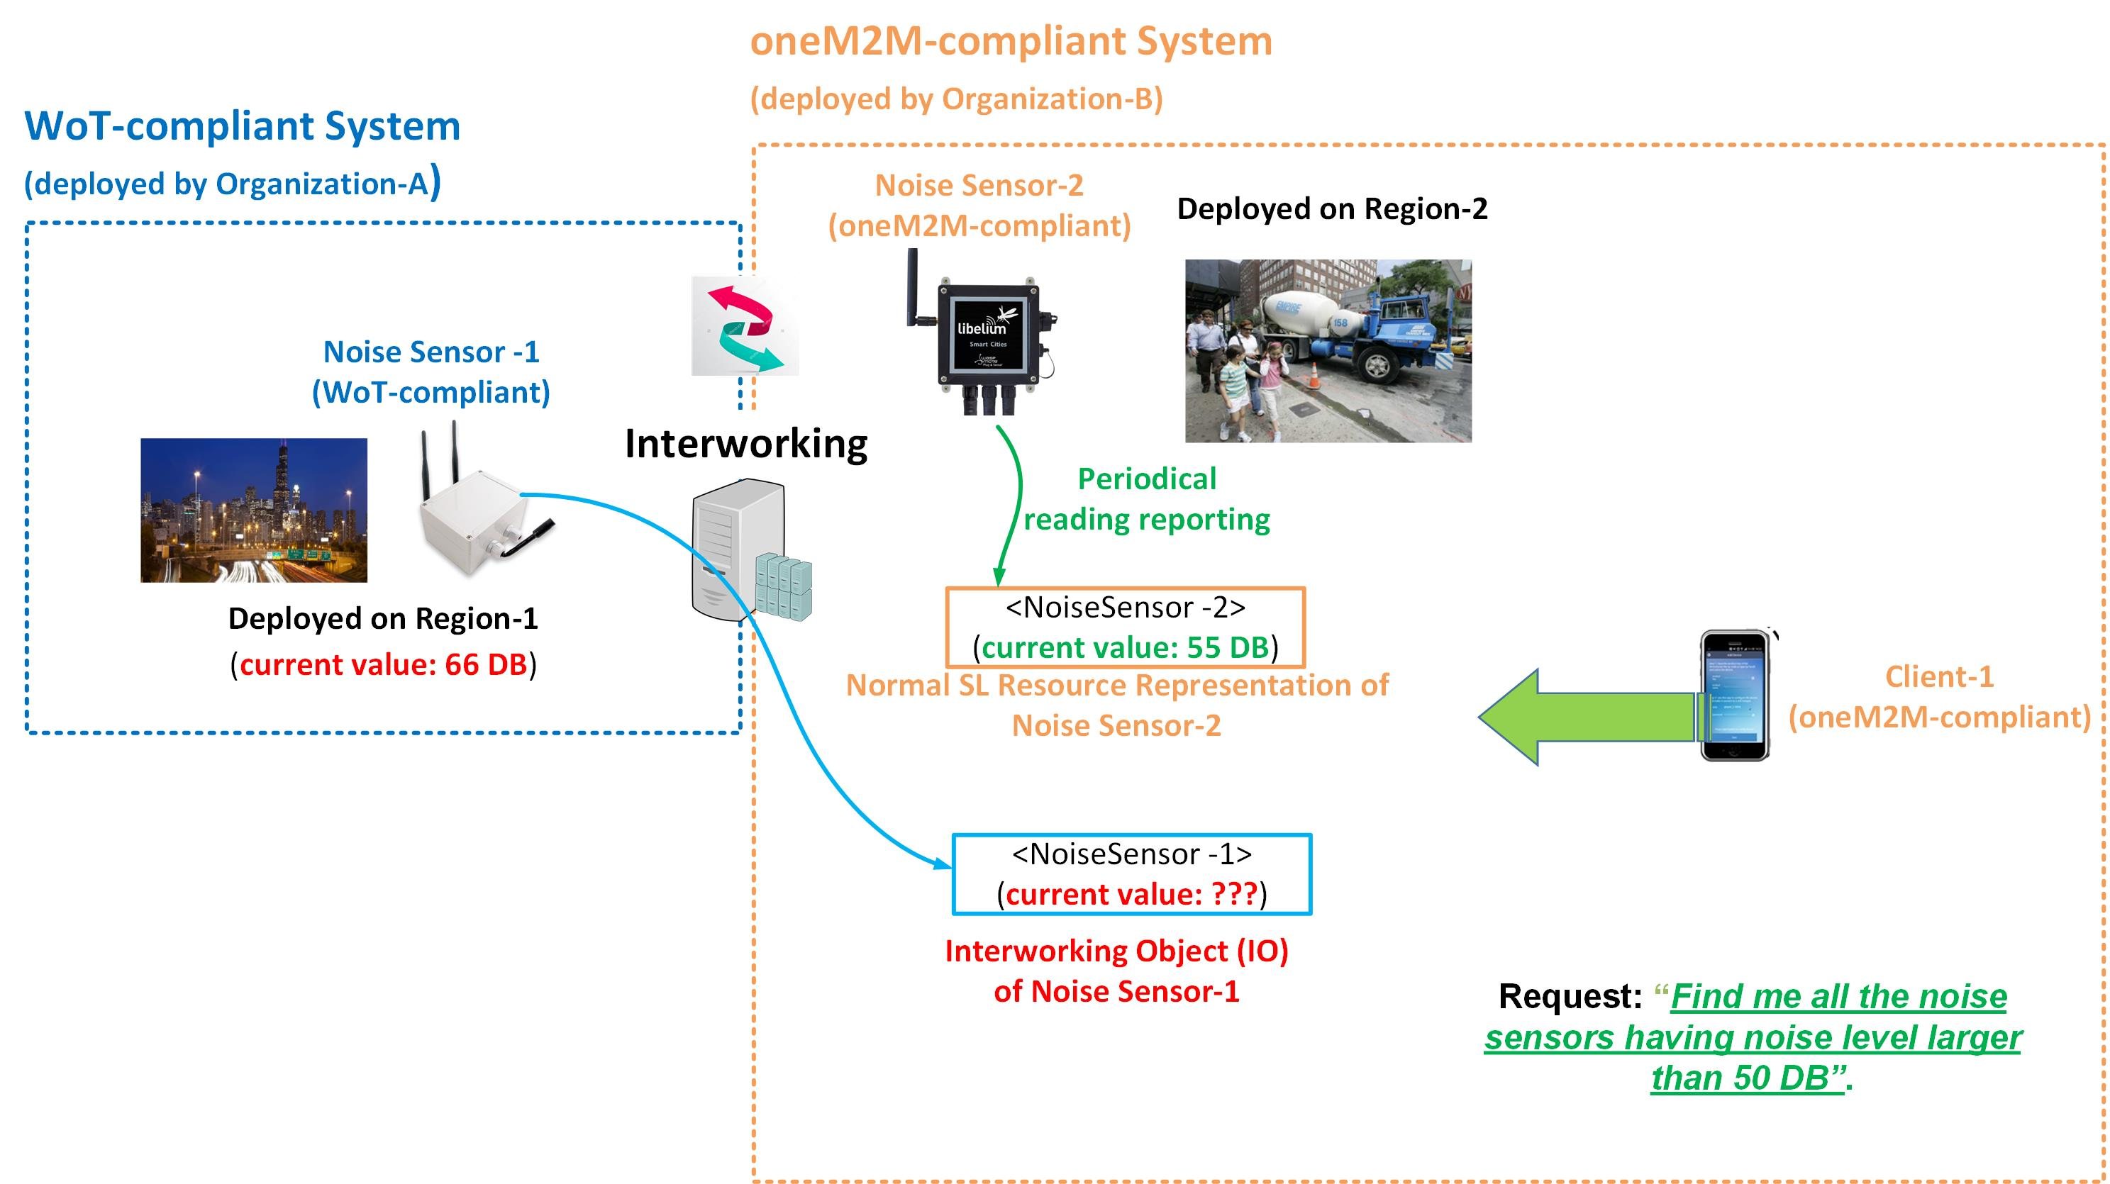
Figure 8.3.1-1 Noise Level Real-Time Monitoring in a Smart City

8.3.2 Overview of Cross-system Discovery Service (CDS)
A Cross-system Discovery Service (CDS) is defined for supporting cross-system discovery between oneM2M and WoT system. In general, CDS has the capabilities to work with both WoT-compliant and SL-compliant access interfaces, which means it can conduct resource operations (e.g. creation and discovery) in both systems. Since WoT native users (such as WoT clients) and oneM2M native users (such as AEs/CSEs) do not have the capability for directly conducting discovery in an external system, the proposed CDS will be a service that can help those clients with two major functionalities: 1) to conduct cross-system discovery in both systems on behalf of clients/users in each system; and 2) to create corresponding IOs for facilitating future access, based on the cross-system discovery results. Note that, for a given device/thing (either a WoT thing or a oneM2M device), the details and approaches of how to create IOs for this device/thing in an external/interworked system are defined in clause 8.2). The proposed CDS is implemented as a service provided by IPE.
As an example, for a given WoT thing that is discovered by CDS and is interested by users in oneM2M-compliant system, an IO (i.e. an oneM2M resource) will be created by CDS in the oneM2M-compliant system such that the oneM2M native users can directly interact with this IO through oneM2M access interfaces. Note that, IOs will have different forms in different systems. For example, a WoT TD can be created in WoT-compliant system for an oneM2M resource representing an oneM2M-compliant device. Such a WoT TD will be an IO for the oneM2M resource. Vice versa, a WoT-compliant device and its TD can also have oneM2M resource representation(s) as IOs being created in the oneM2M-compliant system.

8.3.3 Various Discovery Mechanisms Supported by CDS
Depending on different application scenarios, several discovery mechanisms can be supported by CDS and are introduced in the following sub-clauses.

8.3.3.1 Solution 1: Proactive Cross-system Discovery and Proactive IO Creation
In Solution 1, CDS can “proactively” conduct cross-system discovery in a system (e.g. WoT-compliant system) and then “proactively” create corresponding IOs in another system (e.g. oneM2M-compliant system). In other words, all the operations conducted by CDS are fully decoupled from the discovery operations from clients. For example, with the proactive help of CDS, WoT-compliant devices may have their corresponding IOs in the oneM2M-compliant system in advance. Accordingly, oneM2M native clients can just conduct oneM2M resource discovery on certain CSEs to look for the desired resources (including those being created by CDS as the IOs of WoT-compliant devices), during which CDS does not have to be further involved. Likewise, oneM2M-compliant devices/resources may also have corresponding IOs (in terms of WoT TDs) being created in the WoT-compliant system by the CDS; then WoT native clients can simply conduct TD discovery to look up desired TDs (including those TDs as the IOs of oneM2M-compliant devices/resources).

8.3.3.2 Solution 2: Proactive Cross-system Discovery and Reactive IO Creation
Although Solution 1 may proactively conduct cross-system discovery and create IOs, those operations also incur certain overhead, which may not be always beneficial especially when the created IOs may not be of interest to many clients. Another potential shortcoming of Solution 1 is that it lacks flexibility in the sense that IO creation is purely decided by CDS, without considering the needs from the client side. In fact, if an oneM2M client can ask CDS to discover desired things in WoT-compliant system, it might require that the IOs to be created on a desired CSE and/or as a child resource of a desired parent resource. For example, an oneM2M temperature monitoring application (denoted as AE-1) may ask CDS to discover temperature sensors in the external WoT-compliant system and would request that: 1) all the IOs of discovered WoT-compliant temperature sensors are created on the same CSE hosting <AE-1> resource and 2) those IOs will be the child resources of the <AE-1> resource. To address this need, in Solution 2, it is proposed that CDS can still proactively conduct cross-system discovery in the external system B (either oneM2M or WoT), however CDS will only “reactively” conduct IO creation in the system A (either WoT or oneM2M) only when requested by clients in system A in order to consider their needs.

8.3.3.3 Solution 3: Reactive Cross-system Discovery and Reactive IO Creation
There is still certain overhead for performing proactive cross-system discovery in Solution 2 if it is not worth doing that. Accordingly, in Solution 3, it is further proposed that CDS will fully operate in a reactive manner in the sense that it will be only triggered by the discovery requests. In this solution, CDS not only reactively conducts cross-system discovery in the external system B, but also reactively conduct IO creation in the system A (i.e. all in an on-demand way).

8.3.3.4 Solution 4: No IO Creation Is Created for Each of Discovered Things
In many scenarios, when a client intends to discover things by specifying its needs as discovery constraints, it may further plan to initiate group-based operations over the discovered devices. For example, a client may want to first discover all the noise sensors in Region-1. Once the discovery result is returned to the client, it may subsequently conduct group-based RETRIEVE operations to collect the latest noise level from the discovered noise sensors included in the discovered result. It can be seen that, in this scenario, the client may not want to interact with a specific discovered device. Instead, the client intends to conduct group-based operations over the whole group of discovered devices. As mentioned earlier, IO creation causes certain overhead. Therefore, in order to further reduce the related overhead, Solution 4 proposes that when clients contact CDS for cross-system discovery, they may indicate whether they intend to conduct group operations over the discovered devices, therefore reducing some overhead. In this solution, CDS conducts cross-system discovery in order to keep a local inventory for all the discovered devices. In particular, no IO will be created for each of discovered things/devices but only a single IO (e.g. an oneM2M <group> resource) will be created by CDS for the whole group of discovered devices, which can be addressed and operated by future/subsequent group operations sent from the clients. In other words, the CDS will capture all the requests sending to this IO and then use its local inventory to further accomplish the operation on this group.

8.4 IO Lifecycle Management between oneM2M and WoT Systems
Editor’s Note: It is for further evaluation whether the IO lifecycle management solution in this clause can be generalized to other systems and applied to oneM2M TS-0033.

8.4.1 Introduction
A directly-associated issue related to cross-system discovery is IO lifecycle management. In particular, CDS as proposed in clause 8.3 addresses the client’s needs that clients intend to discover devices/things in both WoT and oneM2M systems. However, once those IOs have been created, another issue is how to manage those IOs in the sense that the status and the lifecycle of those IOs can always be consistent with that of their original devices/things. Still taking the example of city noise monitoring use case shown in Figure 8.3.1-1, the IO of WoT-compliant Sensor-1 in the oneM2M system (i.e. the <NoiseSensor-1> resource) should always reflect the latest status of the original Sensor-1 in the WoT-compliant system.
Without lifecycle management mechanisms between original devices and their IOs, many applications may not be efficiently supported, for example:
- In addition to reactively being discovered by CDS, a newly-onboarded device may intend to be made available proactively in an external system by creating a corresponding IO. This is especially useful in the case where the device owner wants to extend the potential customer scope for more device accesses so that more revenue can be generated (e.g. if a certain amount of revenue will be generated every time the device gets accessed).
- If a device is added with a new operation after its IO was created, such a new operation also needs to be added to its corresponding IO in the external system in order to reflect the latest capabilities of this device.
- Similarly, if an existing operation is not supported/enabled by the device anymore, its corresponding IO also needs to be updated such that this stale operation will be removed from IO.

8.4.2 Overview of IO Lifecycle Management Service (IO-LMS) Description
An IO Lifecycle Management Service (IO-LMS) is defined for supporting interworking between oneM2M and WoT system and an illustration of IO lifecycle management is shown in Figure 8.4.2-1. Similar to CDS, the IO-LMS is implemented as a service provided by IPE.

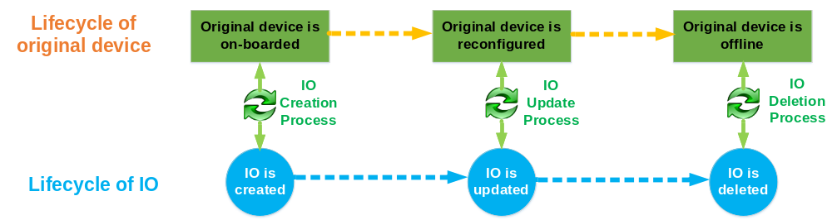
Figure 8.4.2-1 The Illustration of IO Lifecycle Management

In general, for a given device in a System A (e.g. oneM2M-compliant system) and its corresponding IO in another System B (e.g. WoT-compliant system), they should have the same lifecycle and same status. In order to do so, IO-LMS will be involved with the following processes:
• When a device becomes available in System A, its corresponding IO can be created in another System B so that it can also be available in System B. Such a process is realized by IO-LMS through an “IO Creation process”.
• After sometime, if the original device undergoes some reconfigurations, its corresponding IO in System B may also need to be updated to reflect the latest status of the original device. Such a process is realized by IO-LMS through an “IO Update process”.
• When the original device is going to be unavailable, its corresponding IO in System B may also need to be deleted. Such a process is realized by IO-LMS through an “IO Deletion process”.

8.4.3 High-Level Solutions to IO-LMS
IO lifecycle management may happen on two directions (from WoT-compliant system to oneM2M-compliant system and vice versa) and this clause introduces some high-level solutions to IO Creation Process, IO Update Process and IO Deletion Process supported by IO-LMS. Two types of solutions are available for each of those processes, including “original device initiated approach” and “IO-LMS initiated approach”. In contrast, “IO-LMS initiated approach” introduces no actions and no required changes on the original device side, and is preferred by oneM2M.

8.4.3.1 IO Creation Process
- IO Creation Initiated by Original Devices
When a WoT thing becomes available in the WoT-compliant system, it is normally associated with a WoT servient and also have a corresponding TD. In order to make this WoT thing also be available in the oneM2M-compliant system, the WoT servient may proactively contact IO-LMS in order to create a corresponding IO in the oneM2M-compliant system.
Similarly, when an oneM2M native device (as an AE) registers itself to a CSE by creating an <AE> resource, this CSE or AE may proactively contact IO-LMS in order to 1) create an IO in terms of a TD for representing/describing this device and 2) publish this TD to the WoT-compliant system.
- IO Creation Initiated by IO-LMS
In this solution, when a WoT thing becomes available in the WoT-compliant system, this WoT thing as well its WoT servient are not involved in any IO creation related activities. Instead, IO-LMS can proactively conduct TD discovery to identify this WoT thing and decide whether to make this WoT thing also available in the oneM2M-compliant System by creating an oneM2M resource as its IO.
Similarly, when an oneM2M native device (as an AE) registers itself to a CSE by creating an <AE> resource, this CSE and AE are not involved in any IO creation related activities. Instead, IO-LMS can proactively conduct oneM2M resource discovery in order to identify this <AE> resource and decide whether to make this resource also available in the WoT-compliant system by creating and publishing a WoT TD in WoT-compliant system as the IO of this <AE> resource.

8.4.3.2 IO Update Process
- IO Update Initiated by Original Devices
After a WoT thing is already available in the oneM2M-compliant system, there may be some reconfigurations or setting on it (e.g. adding a new action), which also leads to some updates in its TD. Accordingly, this WoT thing may proactively inform IO-LMS such that its corresponding IO in the oneM2M-compliant system can be modified in order to reflect these updates.
Similarly, after an oneM2M device (as an AE) registered to a CSE, its resource representation may undergo certain updates due to any CRUD resource operation. Accordingly, if this device (i.e. its corresponding <AE> resource) was also made available in the WoT-compliant system, the corresponding IO (i.e. a WoT TD describing this device also needs to be updated in order to reflect these updates. In order to do so, a <subscription> can be created by IO-LMS under the <AE> resource in order to monitor any update on this resource.
- IO Update Initiated by IO-LMS
In this approach, IO-LMS can periodically conduct TD discovery in order to see if any TD gets updated. If so, their corresponding IOs in the oneM2M-compliant system also need to be modified in order to reflect the update.
Similarly, if an oneM2M device was made available in the WoT-compliant system, IO-LMS may periodically retrieve the latest representation of the <AE> resource representing this device in order to monitor any update.

8.4.3.3 IO Deletion Process
- IO Deletion Initiated by Original Device
When a WoT thing decides to become offline/unavailable, it may proactively inform IO-LMS for this event such that its corresponding IO in the oneM2M-compliant system can be deleted in a timely manner.
Similarly, when an oneM2M device (as an AE) de-registers to its registrar CSE, this device or its registrar CSE may proactively inform IO-LMS for this event such that its corresponding IO in the WoT-compliant system can be deleted. Alternatively, a notification can be sent to IO-LMS if a <subscription> was created by IO-LMS under the <AE> resource representing this oneM2M device.
- IO Deletion Initiated by IO-LMS
In this approach, IO-LMS can periodically conduct TD discovery in order to see if any TD gets deleted. If so, their corresponding IOs in the oneM2M-compliant system also need to be deleted.
Similarly, if an oneM2M device was made available in the WoT-compliant system, IO-LMS may periodically retrieve the latest representation of the <AE> resource representing this device in order to monitor if it gets deleted.
- IO Deletion Initiated by a Timer
A time period (timer) can be set up when IO-LMS is creating IOs. Accordingly, these IOs will only be valid during that time period as specified by the timer. After timer expires, the IOs will become invalid and can be automatically deleted.

9 Conclusion
Editor’s note: to summarize the present document and to give architectural suggestions for the normative work of WoT interworking in the next phase.

Annexes
Each annex shall start on a new page (insert a page break between annexes A and B, annexes B and C, etc.).
Use the Heading 9 style for the title and the Normal style for the text.
Annex <A>:
Title of annex (style H9)
<Text>
<PAGE BREAK>
Annex <B>:
Title of annex (style H9)
<Text>
B.1 First clause of the annex (style H1)
<Text>
B.1.1 First subdivided clause of the annex (style H2)
<Text>
<PAGE BREAK>

History
This clause shall be the last one in the document and list the main phases (all additional information will be removed at the publication stage).
Publication history
V1.1.1 | <yyyy-mm-dd> | <Milestone>

Draft history (to be removed on publication)
V0.0.1 | 2017-04-06 | Initial skeleton
V0.1.0 | 2017-08-23 | Incorporate agreed input contributions from TP#29:  MAS-2017-0093R01 WoT Interworking Scenarios  MAS-2017-0094R02 WoT Interworking Background for TR-0042
V0.1.1 | 2017-11-16 | Moved the W3C copyright notice to the ‘Copyright Notification’ on the coverpage according to the conclusion of LG#54.  Added Editor’s Note in clause 5.2 to suggest better clarification about which specific part of the content is copied from W3C.
V0.2.0 | 2018-01-18 | Incorporate agreed input contributions from TP#33:  MAS-2018-0001R02-WoT_Interworking_Issues_and_Solutions_for_TR-0042
V0.3.0 | 2018-03-14 | Incorporate agreed input contributions from TP#34:  MAS-2018-0016R03 TR-0042 TD & BO mapping  MAS-2018-0025R02 TR42 WoT SDT Mapping
V0.4.0 | 2018-05-24 | Incorporate agreed input contributions from TP#35:  MAS-2018-0055 TD Updates Based On Recent WoT Progress

